A.I.G.A [Artificially Intelligent GRID Assistant]

Prepared by: | Team GRAS
Faculty | Mr. Mangesh Bedekar
Institute | BITS Pilani, Goa Campus
Date : | 25th September, 2007
TABLE OF CONTENTS

Project overview 3
Project objectives 3
Project scope 4
In scope: 5
Out of scope: 5
Deliverables produced 6
Project assumptions 6
Project approach 7
Design Overview/Workflow : 8
Project Team Information: 9
References: 9

Project overview
We envision a world where information is free, interesting and unifying; a world where technology makes information accessible and more user-centric. Decades ago knowledge was restricted to certain locations across the globe and this resulted in “sporadic knowledge.” Now in the 21st century we face a crisis of information overload and separating the wheat from chaff is essentially what is required.

A.I.G.A - is a complete Grid infrastructure as its backbone (“world”) and can be used to gather this disseminated knowledge. Specialized intelligent bots (“technology makes information accessible”) trained using the free computation cycles (“information is free”) of the Grid and backed with knowledge of all the experts and researchers (“interesting and unifying”) from diversified fields will be ready to answer any question.

Project objectives

Our project aims to create a Grid-Enabled Application that uses the computational power of the GRID and its distributed nature to answer specific queries of students, teachers and professionals alike as accurately as possible in an intelligent and conversational manner. The assistants (or bots) have been designed to be self learning and constantly update their Knowledge bank in response to the nature of queries asked. Other features include virtual classroom, teacher-student interaction, and various business models as mentioned in subsequent sections.

In sum, the project can be said to be made of the following components which we take as the finals objectives as well:
- GRID Infrastructure - An infrastructure for distributing queries and to allow the load to of these queries to be balanced.
- A.I.G.A – An intelligent assistant (or bot) capable of answering the questions of the seeker using the GRID Infrastructure as its backbone
- Knowledge Base – The massive knowledge base forms the database which the assistant is required to search into.
- Interfaces – The most integral part of the project. This would deal with
We aim at building these modules one step at a time and finally combine the power of all 3 to give birth to our project. The first step is to build the GRID Infrastructure. This would require to build a base through which computer could communicate and balance their load amongst themselves. The GRID should be able to sustain the various queries from the users.

Our next step would be building the assistant i.e. A.I.G.A. This assistant should be capable of taking a query from the user in the form a string i.e a question and process it using NLP (Natural Language Processing) to obtain the keywords. These keywords need to be searched up in the Knowledge Base and presented back to the user in a user-friendly and conversational manner so as to make the application very user friendly.

The building of Knowledge Base would be a continuous process. The Knowledge Base is capable of learning answers to new questions as and when queries arrive. Hence we need to build a base capable of storing data in the most compact as well as effective manner so that during the assistant does not face problems during data retrieval.

Finally, the most important part of the project deals with the various interfaces. A product can reach the masses only if its accessible easily. Hence we propose to build various interfaces to A.I.G.A in form of interactive websites, integration with Instant Messengers like MSN Messenger, mobile application with SMS queries,etc.

Project scope
Project Impact:
- A.I.G.A will solve problems in places where experts are inapproachable. Using A.I.G.A, answers to your questions are just a click away.
- A.I.G.A will be initially aimed to cater to the needs of “students and faculty.” It can subsequently be expanded to cover distinct levels in society. We imagine a day to come when farmers will have all their doubts answered, probably even in their native language using a preconfigured self-learning bot.
- A.I.G.A can be used to solve day to day life / health problems by imparting education to users. For example, imagine a database of health based questions. Users can log into the A.I.G.A and feed their health problems which can easily be diagnosed by our “self adaptive educated Bot” whose database is updated on a regular basis. A portal like this can be an ideal location for creating awareness about health hazards like AIDS.
- A.I.G.A realm extends beyond technical education. A.I.G.A can also cater to moral issues in the society. A major problem faced by teenagers is the lack of “sex education.” This can easily be dealt with in a more effective way by having a self adaptive bot which can provide answers depending on the users response and thereby act as a reliable source of information.
- A.I.G.A can eventually prove to be a child's best friend and educator. With advanced features like “voice enabled answers” A.I.G.A can prove to be a common man’s friend. A reliable source of information coupled with interactivity will make this an intelligent prosthesis of education in the global society.

Target Users of A.I.G.A

A.I.G.A assumes different roles for different users as necessary through a Profile Manager. The major functionality on basis of broad user classification is as follows:

Students:
- Answer student queries, clear doubts and educate in conversational manner.
- Course education: teach the student various courses in a conversational and interesting manner. Conventional modes of exams may be replaced by a method where the bot asks a question and corrects the student’s reply immediately. The examination is no longer a “tension” but a wonderful learning experience.
- Enable interaction of students with professors/teachers across the globe to provide an easy learning environment or an interactive workshop and narrow the digital divide.
Teachers:
- Provide access to course content and precise information on related topics through intelligent conversation.
- Allow interaction with students in disparate locations for learning session.
- Encourage the teacher to train the bot so as to effectively educate students.

Other General Users
- Provide an educated platform for accurate replies on user queries. The Ability to follow conversations shall make A.I.G.A an intelligent search mechanism for information on a variety of topics.
  - The interface for other users have been integrated into various existing applications:
    - A.I.G.A Bot in MSN Messenger.

Business Model – Brief Overview
- A.I.G.A enables better education for people in urban and rural areas and provides opportunities for interaction and learning.
- The intelligent conversational bot can also be trained to assume the role of a Help-Desk or Intelligent Assistant for company products.
- By deploying the grid architecture at small scale level, the A.I.G.A framework can be used by companies to educate employees about specific fields.
- All these Applications provide innovative business models for our project.
- In addition, the web-based conversational bot can make use of intelligent advertising (but not violating any privacy policy) for revenue.
- Moreover, teachers/faculty can chose to provide their services (for learning sessions or workshops) for both free and charge, according to their will making it an ideal platform to serve the public as well as an opportunity to earn revenue.

The scope of this project includes and excludes the following items.

In scope:

Components of A.I.G.A
- The Webservice: The A.I.G.A webservice is responsible for authentication and serves as a broker between client Applications and the central Application Manager of A.I.G.A. In some sense, it acts as the middleware between client and the “real” server – i.e. the Central Manager of the GRID Framework.
- User Interface/Client: This is the primary mode of interaction for the user. We have built several different user interfaces for interaction with the user:
- A Client Application for students. Provides an easy to use interface with the bot as well as addon tools such as calendar and schedule…
- The web interface is an interface providing a facility to converse with a general (as opposed to specialized) bots for educational and informational purposes.
Central Application Manager and the GRID Framework:
- One of the most important component of our project
- This is the backbone of A.I.G.A and supports the bots.
- The intelligent Bot based on AIML

Out of scope:
The Following Are Features of the Project that are currently out of scope, which cannot be worked upon in the time period allotted to complete the project but these features are feasible.

Learn Assistant
- A.I.G.A makes use of Search API in order to obtain latest and accurate information on frequently asked topics from the world wide web

Profile Manager
- Used for managing profile of users and personalization of information.

Data Harvesting:
The Grid Infrastructure Can Handle Large amount of Data but “Data harvesting“ i.e creating A.I.M.L Files using search APIs & Other methods of data harvesting are currently out of scope.

Deliverables produced

Development Technologies Used:

- .NET Framework 2.0
- .NET Framework 2.0 based Alchemi toolkit library for construction of Grid architecture
- Ms Conference XP (A Microsoft Research Initiative) framework
- Visual Studio Express Edition 2005
- AIMLBot Class in C# (www.aimlbot.sourceforge.net)
- Microsoft SQL Server 2005
- Microsoft IIS Server Version 5.1
- ASP.NET 2.0, ASP.NET Web Services
- Smart Device Client Application
    - Application Interface for Pocket PC 2003
    - Application Interface for Smartphone 2003
    - Application Interface built for Windows CE 5.0 or later.

The Project Consists Of Following Deliverables :

- A Client Application for students. Provides an easy to use interface with the bot as well as add-on tools such as calendar and schedule.
- The web interface is an interface providing a facility to converse with a general (as opposed to specialized) bots for educational and informational purposes
- A Windows Vista Sidebar Gadget.
- A Mobile Interface which acts as a client designed to be used on Windows Mobile 6.0.
- A WML Interface to give access via GPRS/EDGE.

- The Webservice
  - The A.I.G.A webservice is responsible for authentication and serves as a broker between client Applications and the central Application Manager of A.I.G.A. In some sense, it acts as the middleware between client and the “real” server – i.e. the Central Manager of the GRID Framework.
- Central Application Manager and the GRID Framework:
  - One of the most important component of our project
  - This is the backbone of A.I.G.A and supports the bots.

Project assumptions
In Order to implement the project, the following are assumed:
- All the Computers that the GRID consists of must have .Net framework 2.0x
- In order to support the GRID, the nodes should be on a network with support for protocols such as TCP/IP

Project approach

The Project Outline is ready as per the Details given above in this document. The Project can be divided into three basic phases:

Analysis: In this phase all the team members are required to closely to analyze the Problem which the project is aiming to solve. For example, identifying different user scenarios.
This Phase is almost over for the team.
Design: In this Phase, The Project team will come up with the complete software design & then will implement the Design Model by producing deliverables.
The project team is currently working on this phase.
Testing: After the deliverables are produced, The Project team will try to test the software with all possible inputs. For example, testing the Authentication Web Service, load balancing etc

Design Overview/Workflow :

Intelligent



Conversational
GRID Framework

Self Learning
GRID of computers

Accurate
Target Users
- Students
- Teachers
- Researchers
- Other Users
A.I.G.A

Knowledge Base






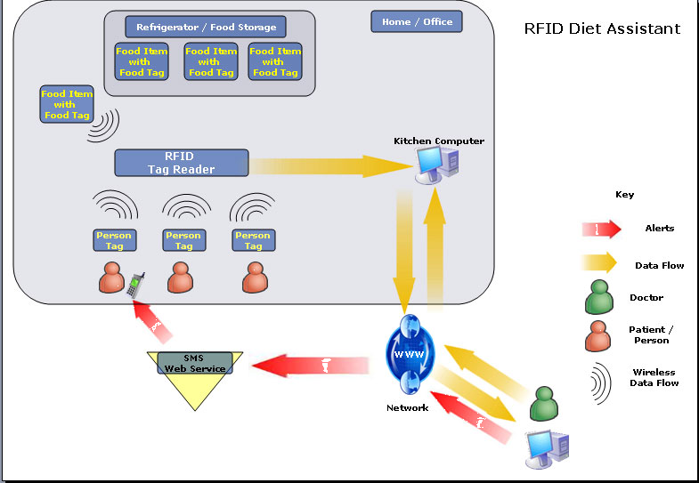
User Interfaces

Client App
Windows Sidebar Gadget
Microsoft Office Integration
Webservice
Smart Devices
Central GRID Manager
Generic Executor Pool
Constant update from Web

Either Google API or Windows Live API

The World Wide Web
AIGA
USER

Several Specialized Executor Pools with sub managers

Project Team Information:
Core Team Role | Name(s) | Phone Number(s) | Email Address(es)
Faculty | Mr. M .Bedekar |  | mangesh.bedekar@gmail.com
Team Member | Roshan Sumbaly | 9372411280 | rsumbaly@gmail.com
Team Member | Abhishek Kumar | 9823981721 | abhishek.kumar.ak@gmail.com
Team Member | Shubham Malhotra | 9370078007 | shubh.malhotra@gmail.com
Team Member | Gaurav Paruthi | 9823221767 | gparuthi@gmail.com

References:
- www.gridbus.org/papers/Alchemi.pdf - Alchemi Framework for Grid Applications
- www.alchemi.net
- www.microsoft.com/windowsmobile
- www.alice.org

______________________________________ ___________________
Faculty – Mr.Mangesh Bedekar Date : 25th September

______________________________________ ___________________
CSC Mentor– Vishal Bansal Date

